IE2 Administration User Guide


Contents
Creating Users Accounts …………………………………………………….3
Users Groups ……………………………………………………………….......4
Unrestricted Access ……………………………………………………………4
Single Sign On Authentication ID ………………………………….......5
Password Resets …………………………………………………………........6
Archiving User Accounts …………………………………………………….6
Locked Accounts …………………………………………………………........8
Structure Application - Registering Sites ….…………………………9
Assigning User Access / Permissions ………………………………….10
Record permissions report ....................................................13
Managing Lookup Lists……………………………………………………….14
Audit Logs ………………………………………………………………………….15
Data Archiving ……………………………………………………………………16
Help / Guidance Documents Upload ………………………………….19

Creating Users Accounts
From the Homepage, click on the Administration module from the top menu bar, which will bring you to the Users page:
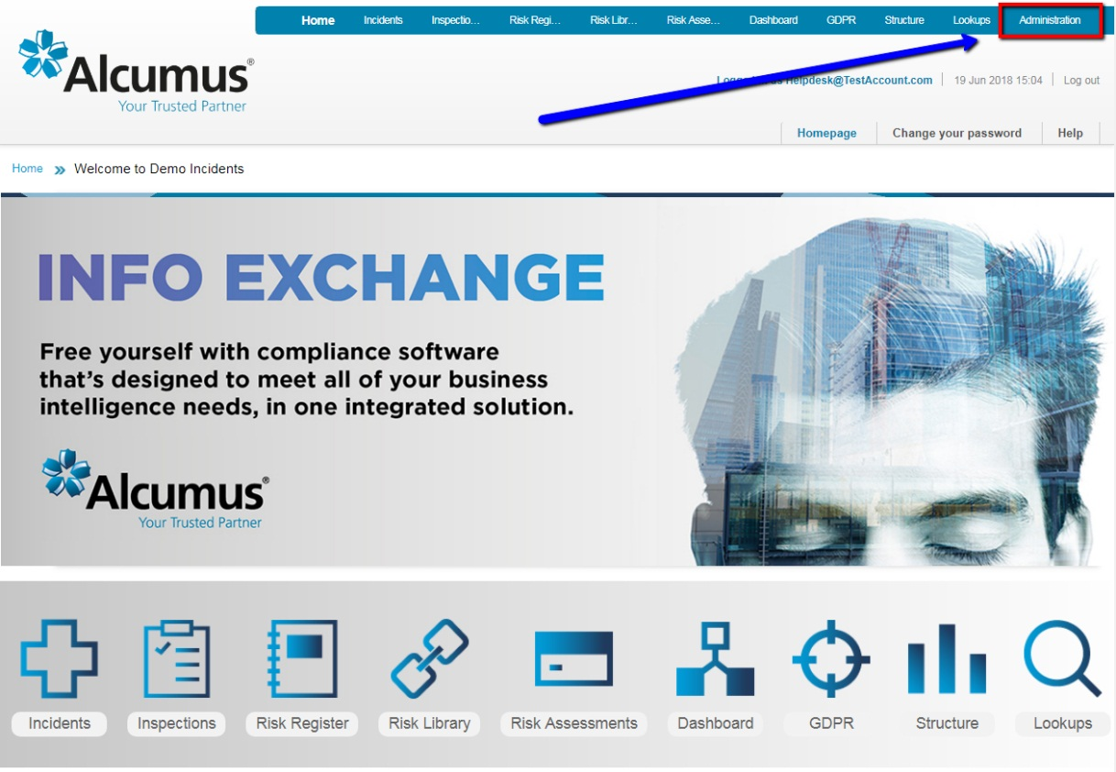

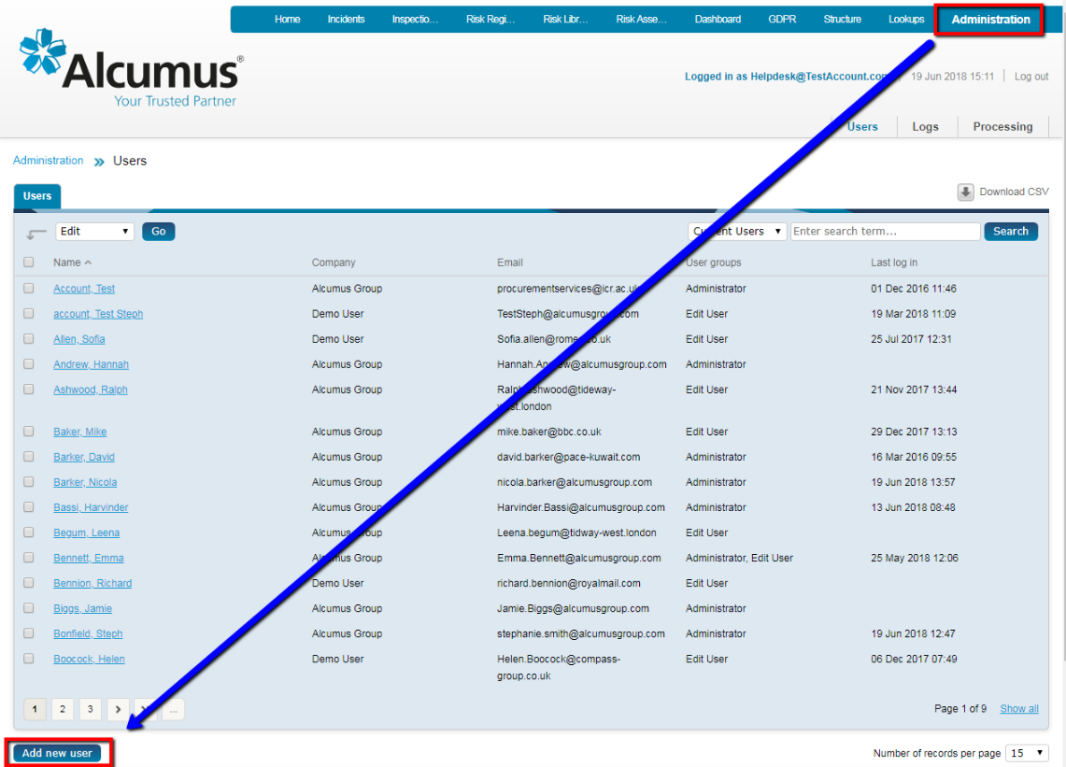
On the Users page, click the “Add New User” icon as shown:

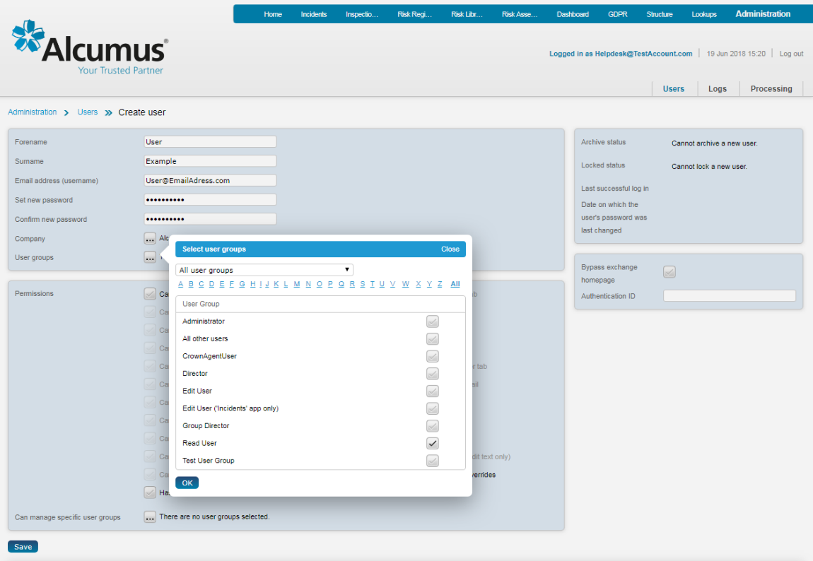
Complete the following fields in the top section, shown below:
- Forename
- Surname
- Email Address
- Set a new password for the user and confirm the same password on the next row
- Select Company
- Choose one or more User Groups from the pop-up menu, depending on the required level of access – see next section for further information on User Groups.

After completing the top section, click “OK” on the User Groups pop-up menu and then click “Save” at the bottom of the page to create the user account.
A user account can be edited at any time by selecting a user from the list in Administration > Users.
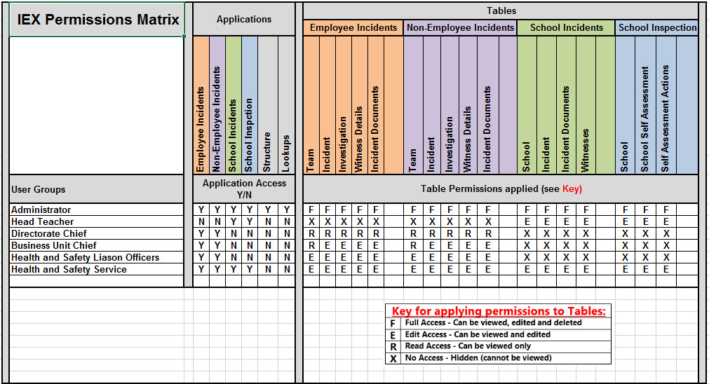
User Groups
The Permission Matrix document produced during the configuration process details the agreed User Groups and permission levels (see example).
This should be used as a reference when assigning one or more User Groups to a user account.

If any changes are required to the Permissions Matrix, such as a change to the level of permissions for a User Group or a brand new Group is needed, please update your copy of the Permissions Matrix with the requested changes and send to the Alcumus Info Exchange Helpdesk team to ensure that the new permissions are applied into the system.
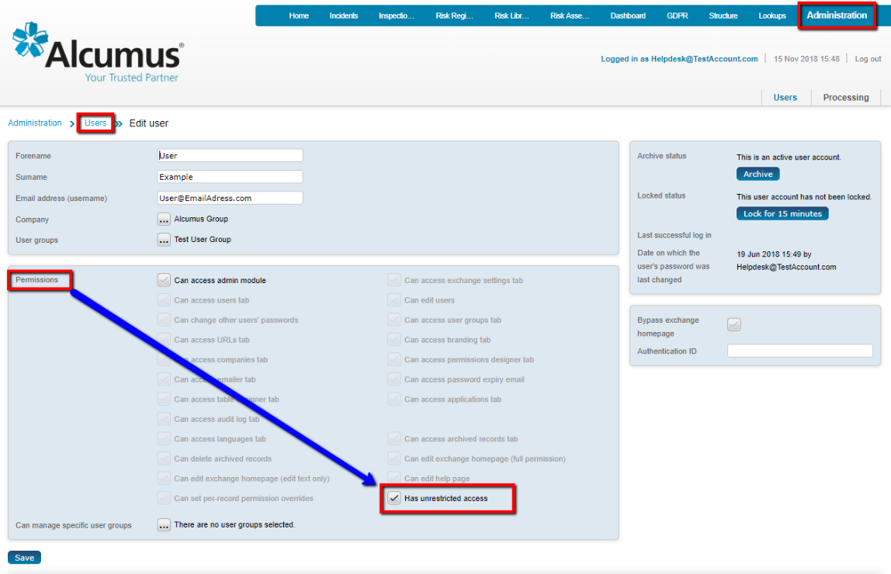
Unrestricted Access
Users who require access to all data tables and all records can be given Unrestricted Access on their user account to avoid the need to apply multiple specific business structure/site location permissions.
Unrestricted Access is applied on the Users page - edit the user account and tick the “Has unrestricted access” box in the Permissions section of the page

*Please note that unrestricted access allows the user to view, edit and delete all records in the entire database, and should be reserved for Administrators of the system only.
Single Sign-On Authentication ID
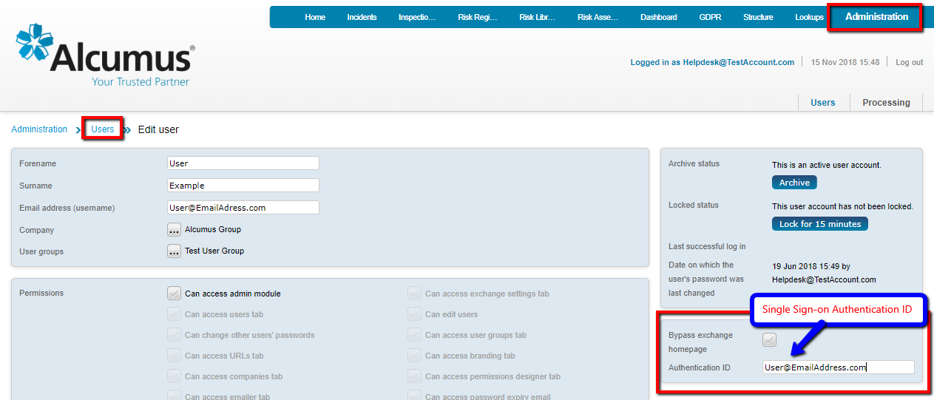
All user accounts requiring Single Sign On authentication from another system must have the ‘Authentication ID’ box populated with the corresponding identifying ID. This value must be unique – duplicate values across user accounts will cause the SSO to fail and the user must then login in manually with their username and password.

Password Resets (does not apply if users are utilising Single Sign-On)
To reset a password for a user who has forgotten their login credentials, click on the Administration module from the top menu bar, which will take you to the Users page.
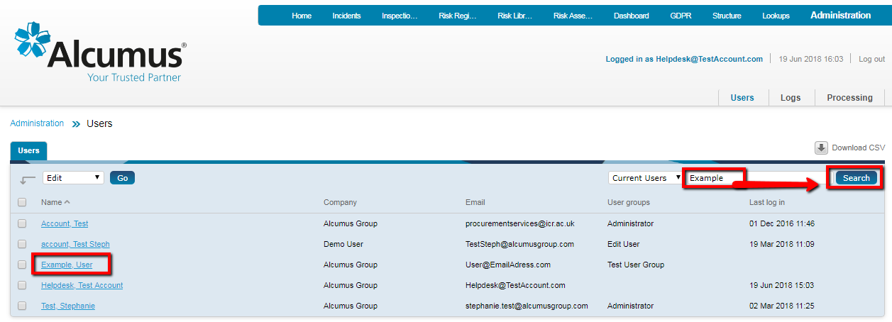
Find the user record using the quick Search box and click on the name of the user to edit their profile.

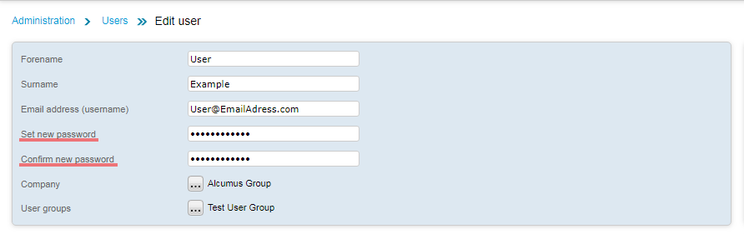
Set a new password and then confirm the new password and click the Save button at the bottom of the page.

Please note that your exchange may have password rules in place such as a minimum number of characters, mandatory inclusion of numbers, capital letters and/or punctuation. If the password does not meet the minimum requirements a message will appear on screen and a new password must be entered and saved.

Archiving User Accounts
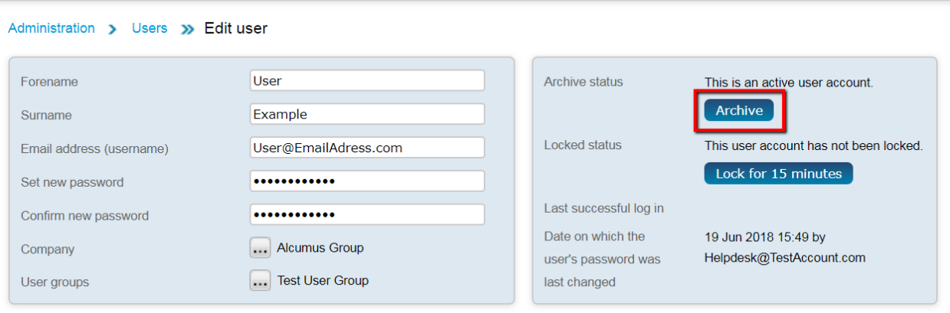
To archive a user that no longer requires access to the exchange, edit the user account and click the Archive button on the top right-hand side of the Users page, then Save

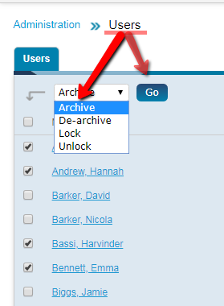
It is possible to archive a number of user accounts at one time; this can be done by ticking their names on the Users page, and selecting Archive, then Go on the drop-down window just under the Users tab.

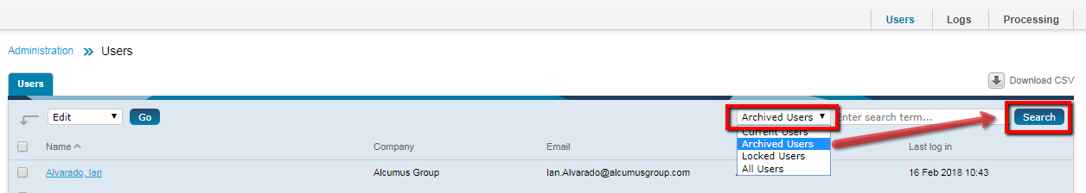
Archived users can be accessed from the list of Users by selecting Archived Users from the below drop-down menu.

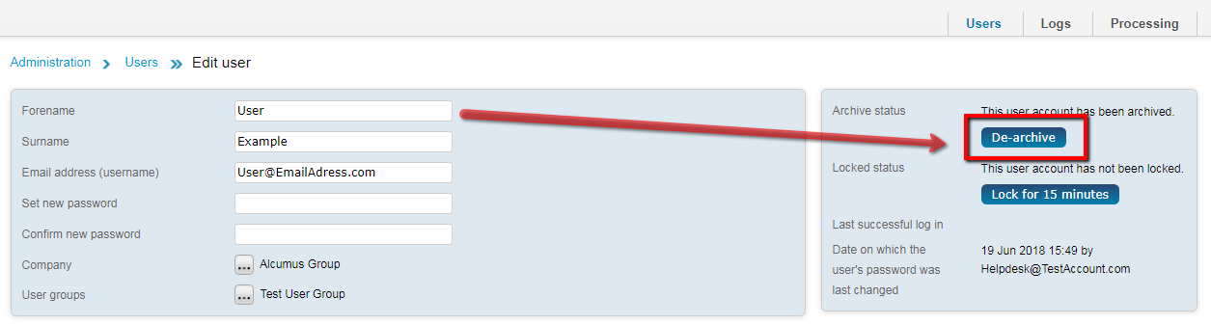
To De-archive a user, select their user account from the Archived Users list (editing the user page), then click on the De-archive button.

Locked Account
If a user has entered an incorrect password more than the permitted number of times (usually 3), then the user account will be locked for a set time period (usually 15 mins).
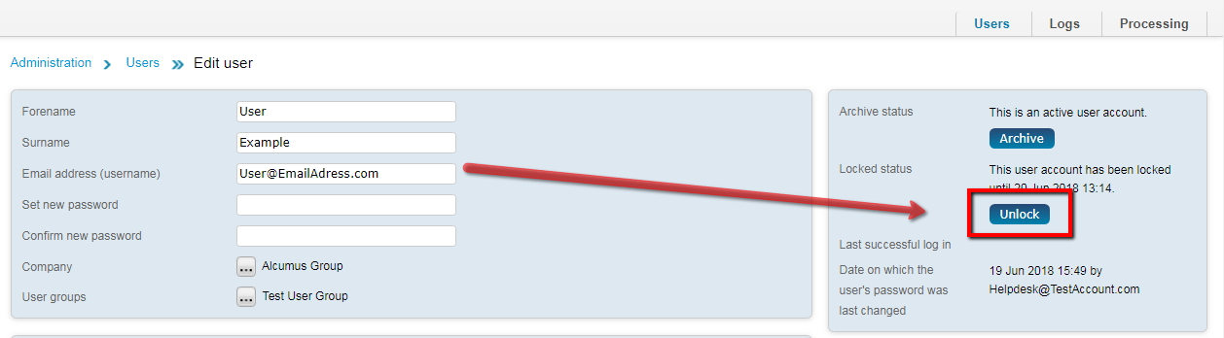
The Administrator can unlock a user account by editing the user profile record and clicking the Unlock button located on the right-hand side.

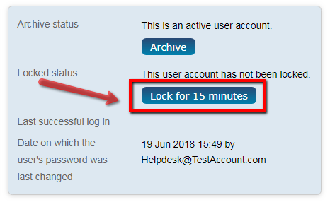
An Administrator can also lock a user account for a specified time period using the Lock for 15 minutes button.

Structure Application - Registering Sites / Properties / Offices / Projects / Businesses / Schools / Properties / Regions, etc.
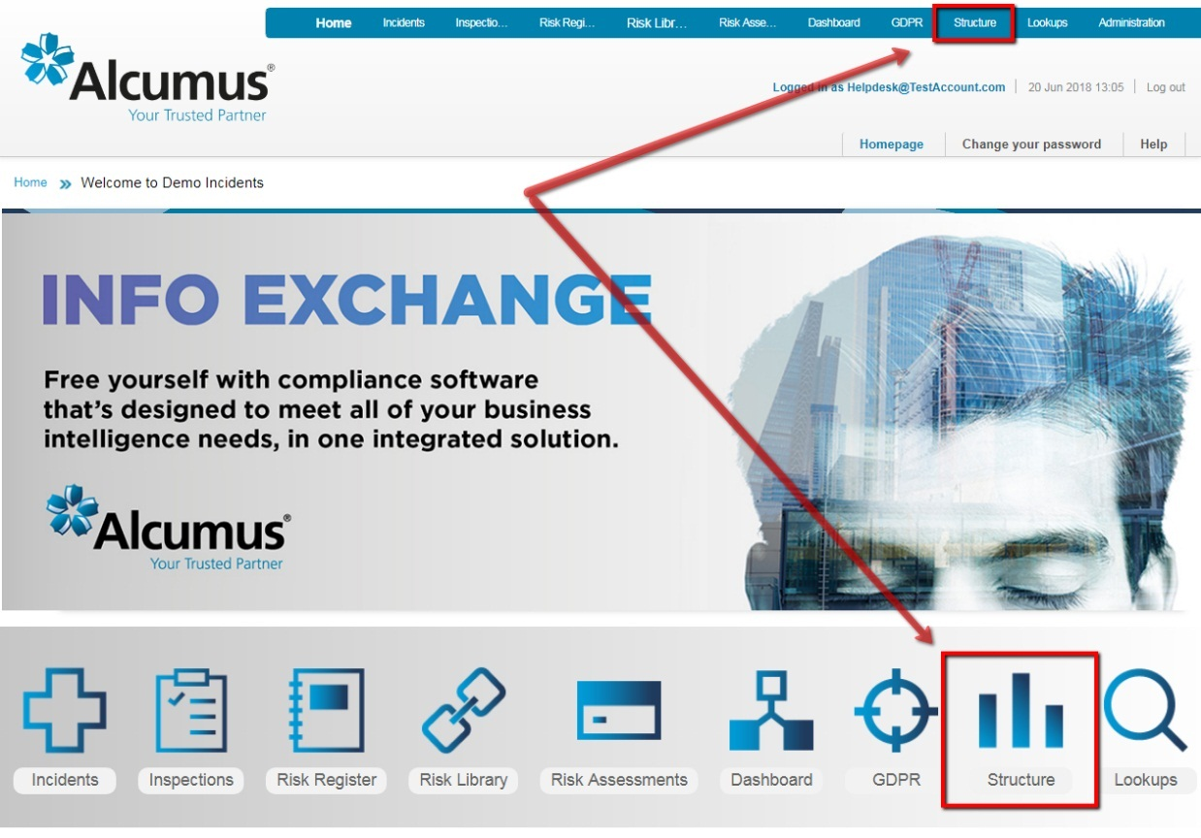
Click into the Structure application; this module houses the Sites (this may be called Properties, Offices, Projects, Schools, etc., depending on the specific organisational structure - this guide uses the terminology ‘Sites’), along with all corresponding data assigned to each Structure level.

Click on the ‘Create new Site’ icon.
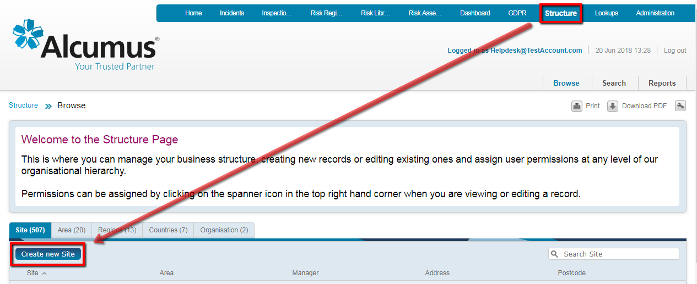

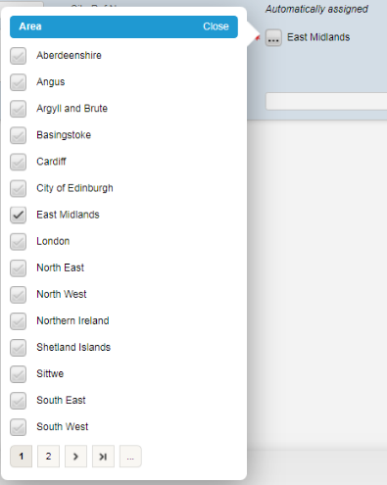
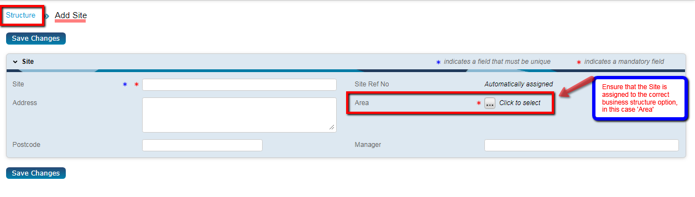
Complete all mandatory fields plus any additional fields that can be populated.

It is important to assign the Site to the correct business structure options e.g. Area / Business Unit / Division. This data is used for both reporting of data and applying user permissions.
Click Save Changes to register the Site record for use in any of the IE2 applications.

Assigning User Access / Permissions
Once user accounts have been created and Sites have been added to the Structure, it is possible to assign user access permissions.
Permissions can be applied to any records in the system at any layer in the database Structure. This means permissions can be granted to an individual Site, an Area above a site or a Region above an Area, all with one simple permission override assignment.
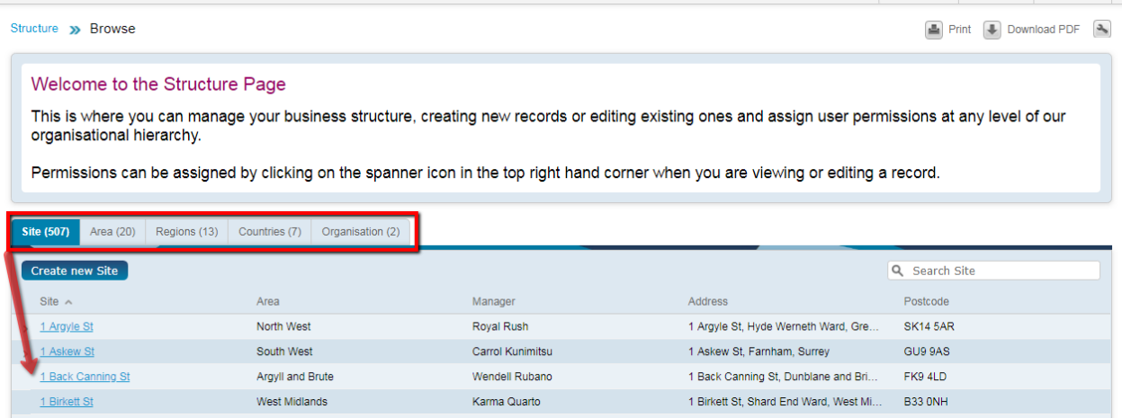
First, on the Structure page, select a record that best fits the user’s permission needs – perhaps a Site or Area.

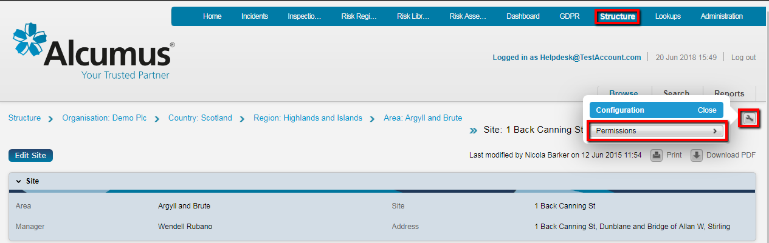
Once a Site has been selected, you will be taken to the summary page; click the spanner icon in the top right corner and select Permissions.

The Permissions page is split into four sections, as below.
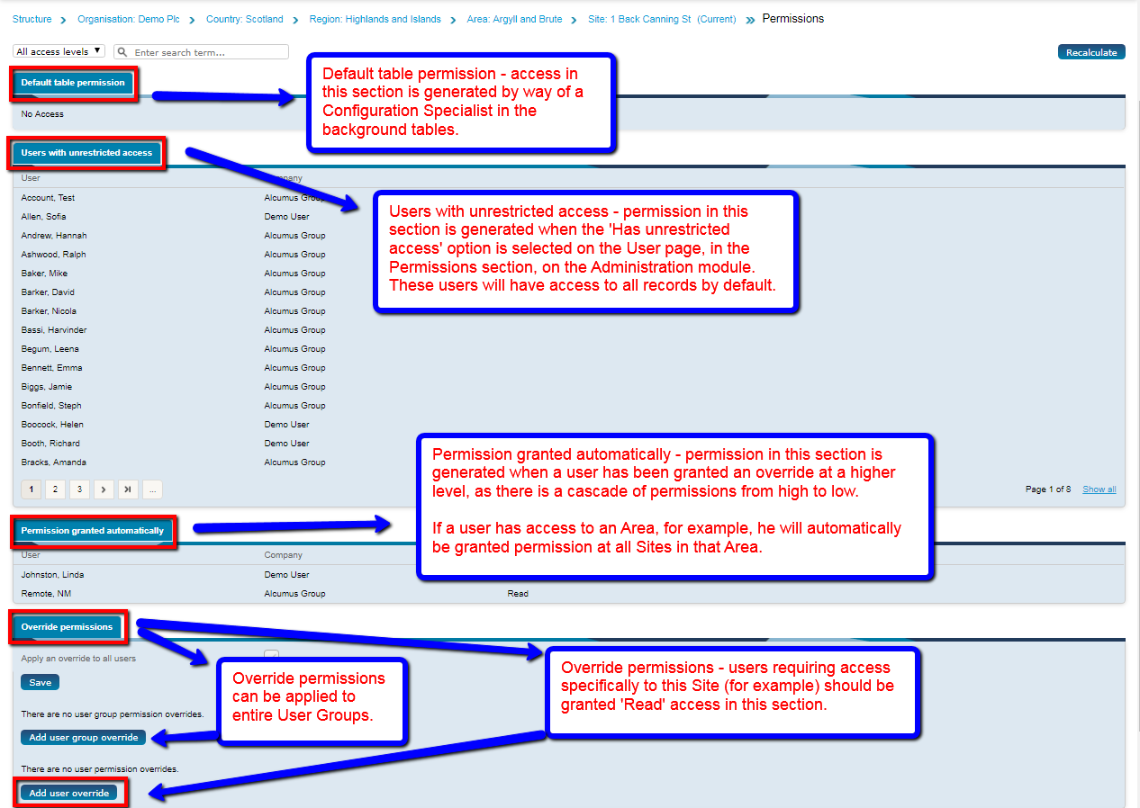

Users assigned Unrestricted access are in the second section and will have access to all sites by default.
Some users will be granted Permission automatically to this site due to access at a higher level. A user with access to a related Area will be granted access automatically to all sites within that area.
Any users (or User Groups) requiring access specifically to this record should be granted ‘Read’ access in the Override permissions section (at the bottom of the page).

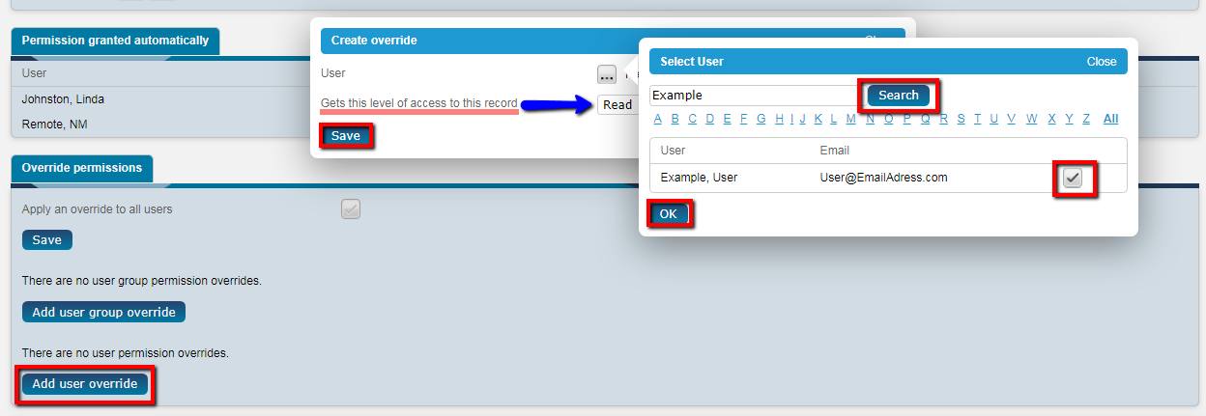
Click on the “Add user override” button at the bottom of the page and select the user from the list. There is a quick search box at the top of the users list.
Click OK when the user has been selected and then choose ‘Read’ access from the dropdown list. Click Save once the user and access level has been assigned (see below).

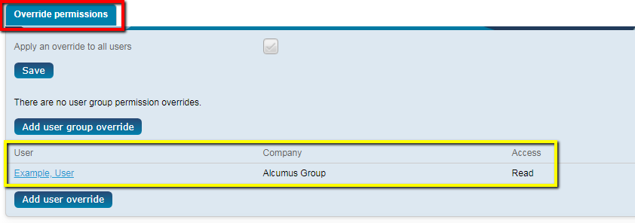
Read access will allow the user to read details of this record (Sites) but not add new records or make any changes. When applying Override Permissions – please note that most users should be assigned read access to Sites / Areas, etc. this ensures their inherited permissions flow correctly (as per their User Group – see Permissions Matrix). It also ensures they cannot edit the record (Site) - change the Site Name or Postcode for example!
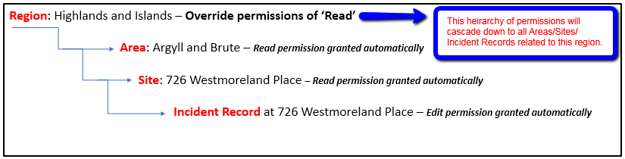
Users with Read access will automatically inherit the appropriate level of access to data that is associated to their User Group – see example hierarchy and permissions

Full access will allow the user to delete records in addition to edit access – this should only to be given to Administrators.

Record Permissions Report
A report can be generated from each application to review users and which record permissions they have.
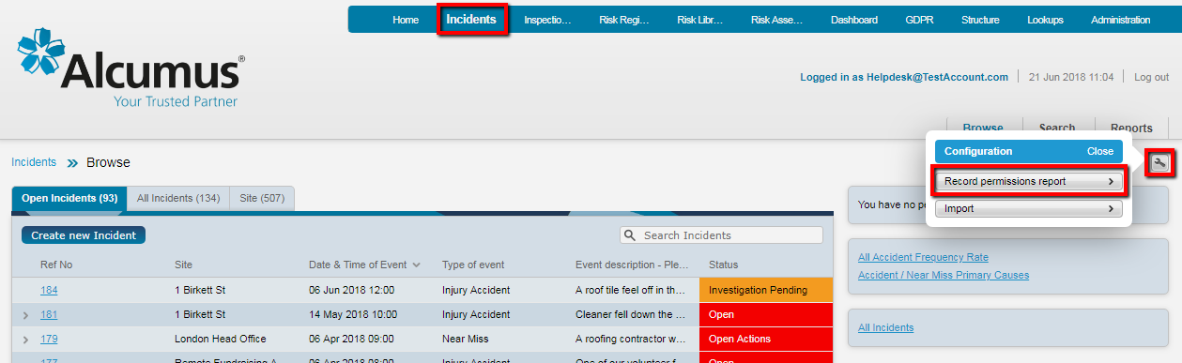
From the application homepage (in this case, the Incidents application), click the spanner icon and select ‘Record permissions report’.
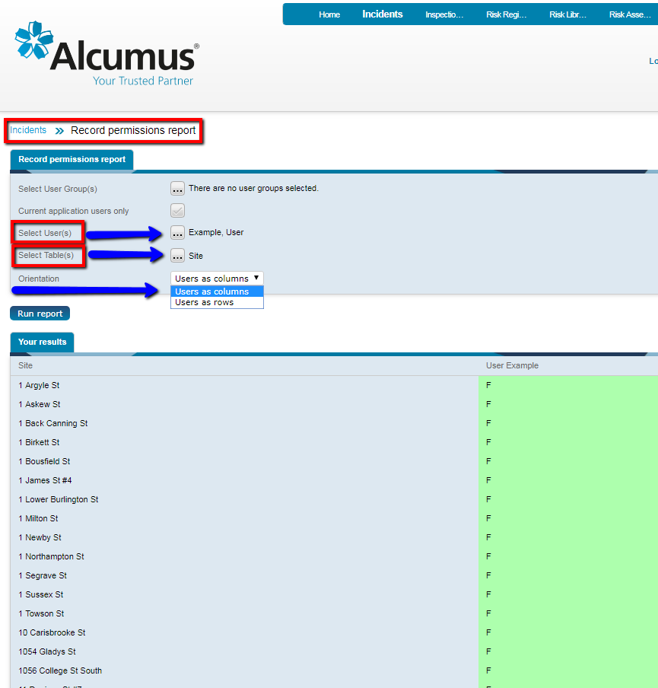
Select the User Group(s) or User(s) to be included in the results, then
Choose the Table(s) to be included when identifying which records the chosen Users/User Groups have permissions for.
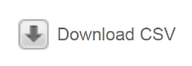
Select either Users as columns or Users as rows in the Orientation field, and click Run Report.
Results can be downloaded to CSV if required.

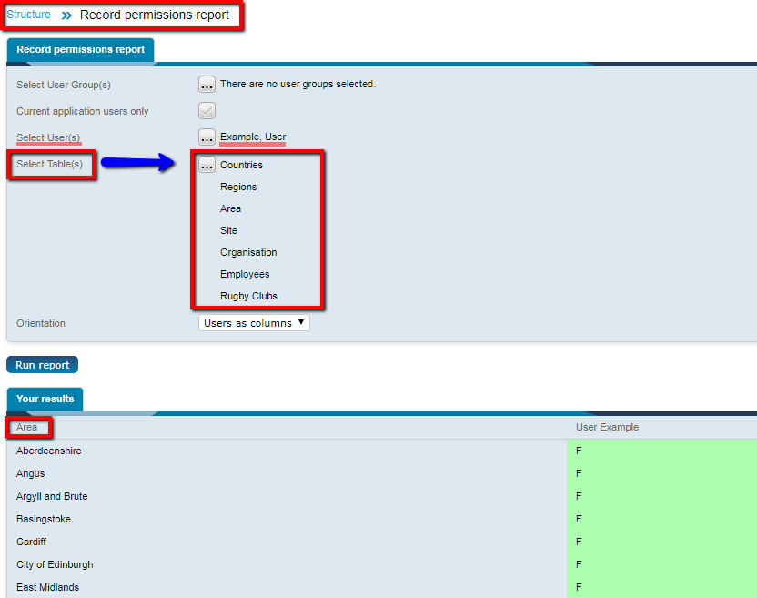
This feature is useful when checking to see if a User / User Group has been assigned to the Structure, and can be used in the Structure application to determine which level of access users have been given, at which level (see example):

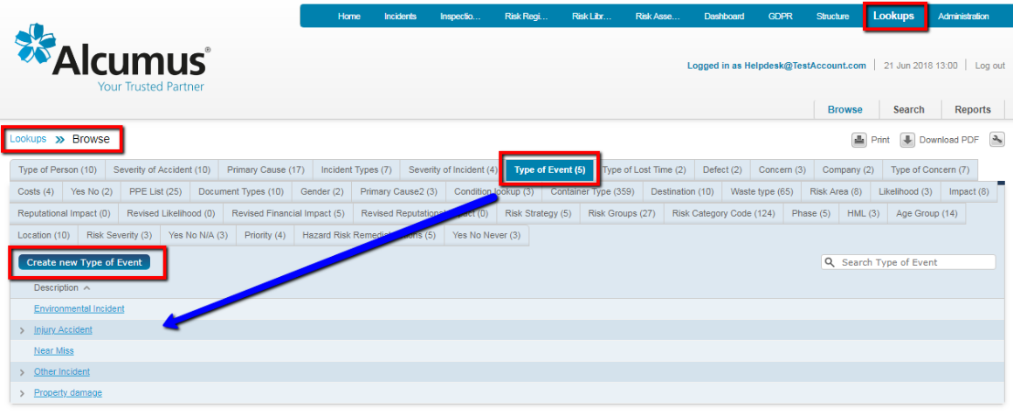
Managing Look-up Lists
A Lookups application is provided for managing the look-up lists (drop-down menus) associated with all applications.
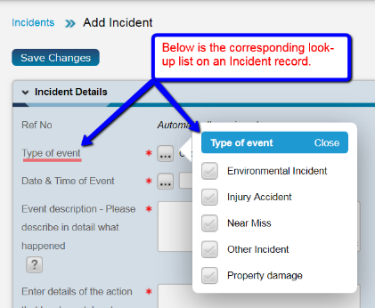
Look-up tables are grouped under headings representing the application the lists belong to. These groups are collapsed by default – click on a group heading and the available lookup tables will expand out.
To create a new look-up, click on the tab for the required field (in this case, Type of Event), then click the Create New button (Create new Type of Event, in the above example).
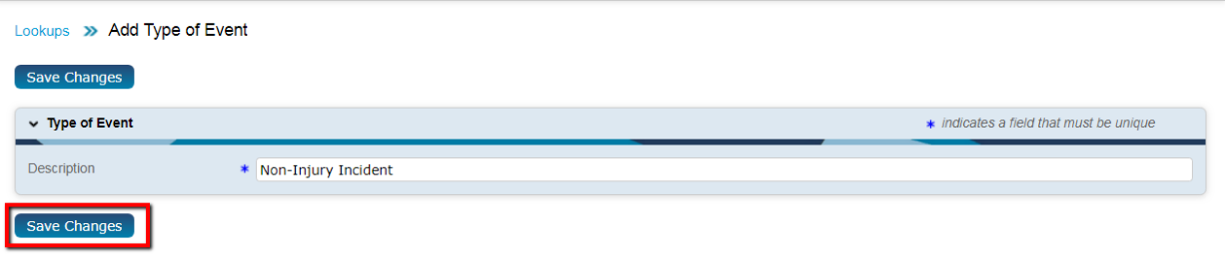
Enter the required details into the Description field and then click the Save changes button.
To edit an existing entry, select the record from the list and click the Edit button. Make the required amendments and then click Save Changes.

Audit Log
The system audit log provides a full history of all activity by all users; the audit logs can be reviewed and interrogated by Administrators.
To access the Audit Log feature, select the Administration module from the top menu bar and then choose Logs.
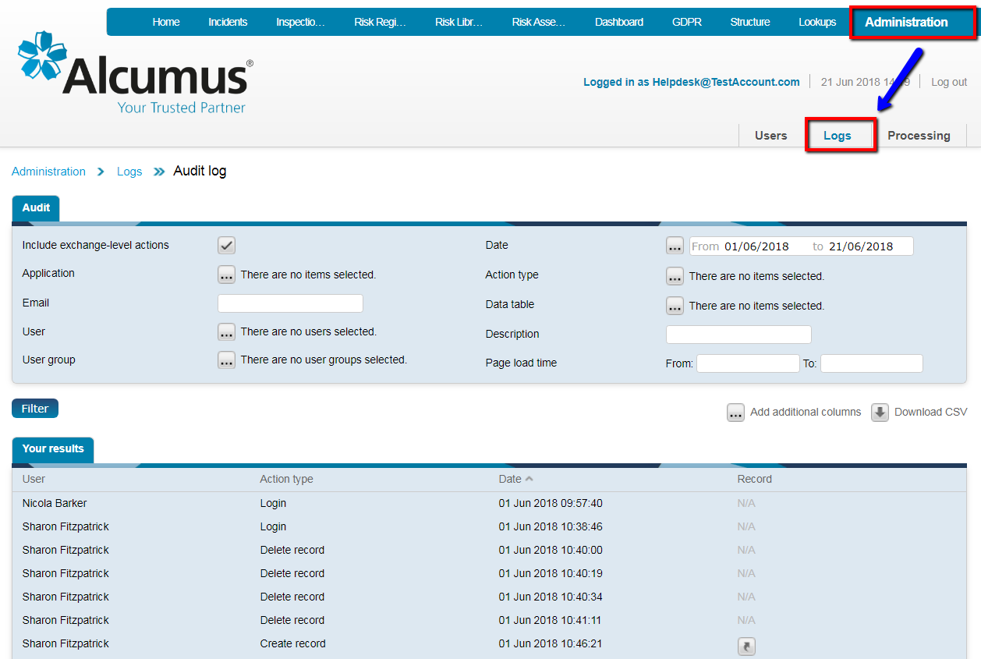

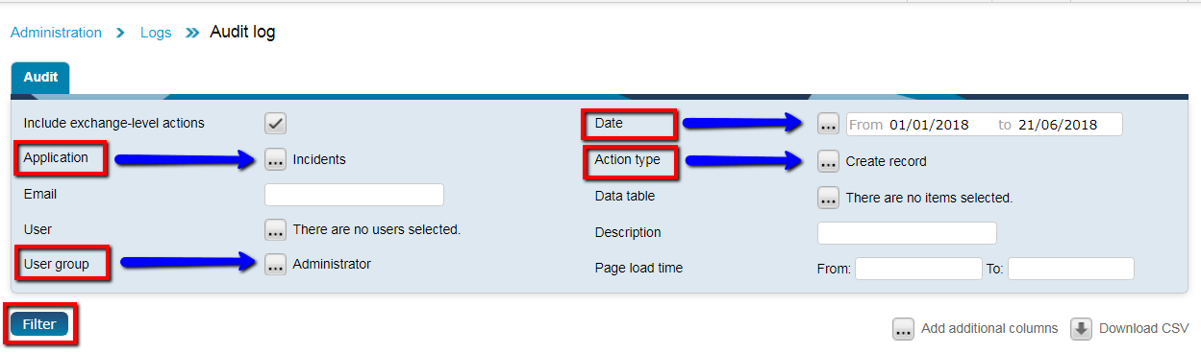
The top half of the page provides a wide range of filters to allow the Administrator to select specific search options when interrogating the audit log for information.
Filtering can be applied by Date, Action Type, User, User Group, Application plus many more. Make any combination of search filters and then click on the Filter button to generate the results.

On the bottom-half of the page, it is possible to Add additional columns, to add any further information to the result set. Once all relevant options have been selected, click on the Filter button to generate the required data.
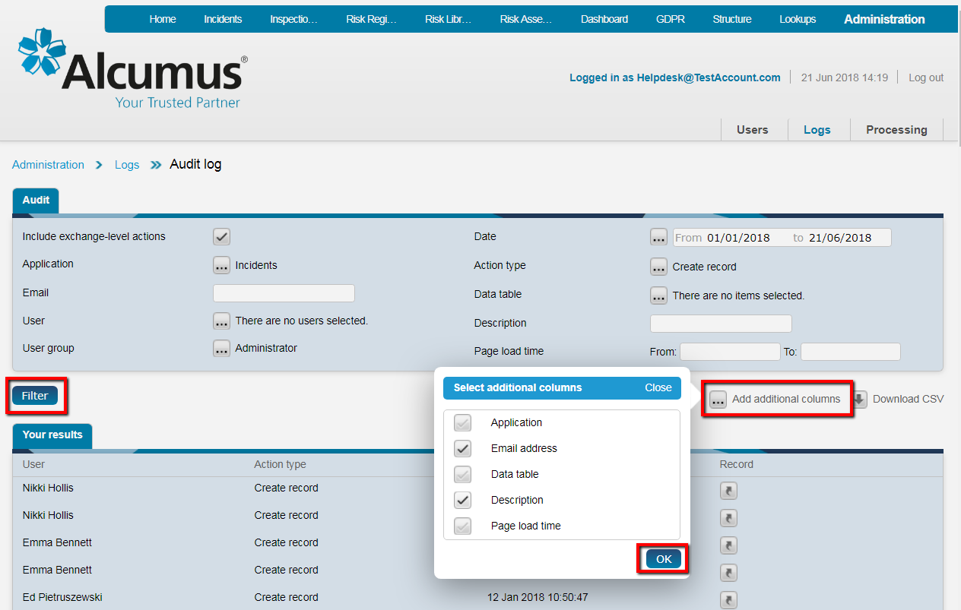
Results can be download into Excel using the Download CSV button.
Data Archiving
A Data Archive function is available providing the ability to archive selected records and move them to an archive area of the exchange.
Archived records are removed from a main application and stored in a permission controlled Admin area, accessible via a downloadable CSV / ZIP file, containing documents.
Administrators are able to utilise this feature by merely deleting records; once a record has been deleted, it is stored in the ‘Archived records‘ section, which can be found on the Administration module.
Authorised Administrators will then have the option to permanently delete from the Archive area, completely removing records, as necessary.

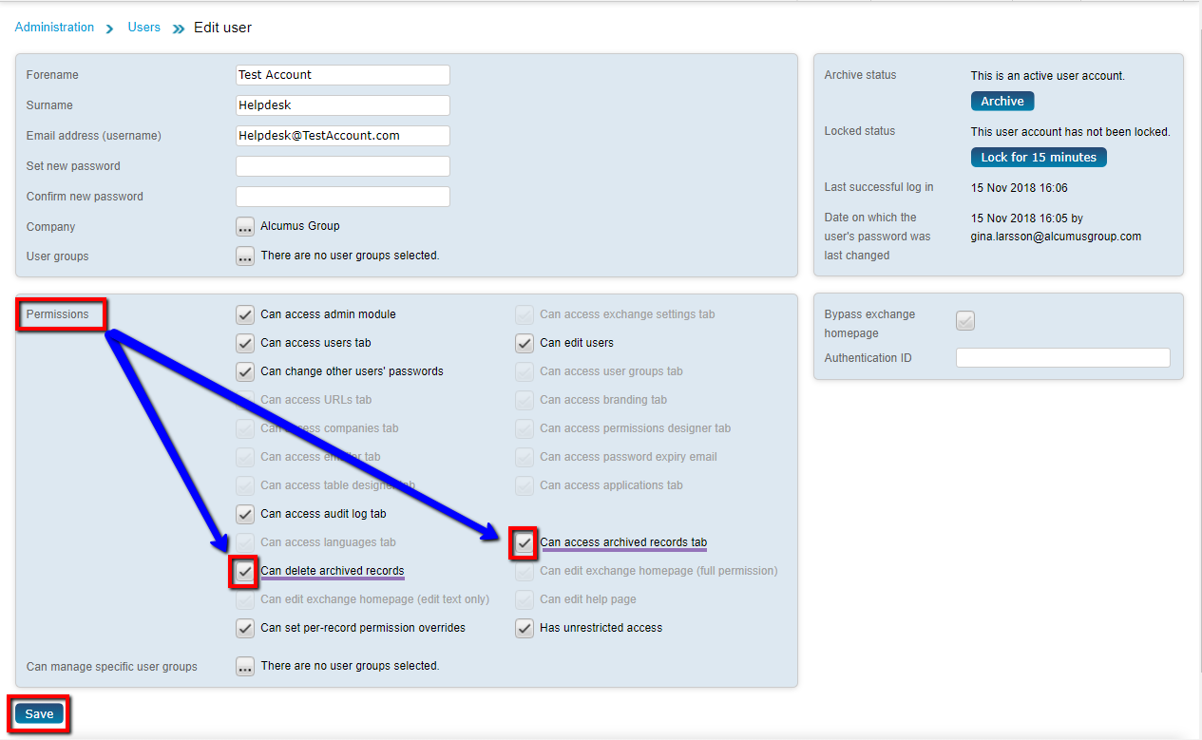
To give an Administrator the ability to archive records, go to the Administration module, click on the Users page, and search for the user account. Click on the account, and in the ‘Permissions’ section, select the ‘Can access archived records tab’ and ‘Can delete archived records’ options, and Save:

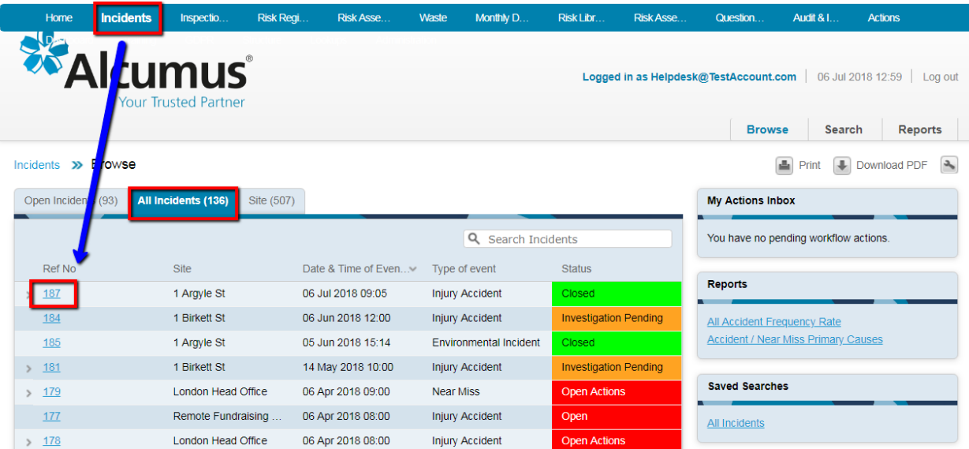
To archive a record, go to the desired application; in this example, the Incidents module, and select the record you would like to archive.
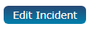
On the Incident page, click on the ‘Edit Incident’ icon

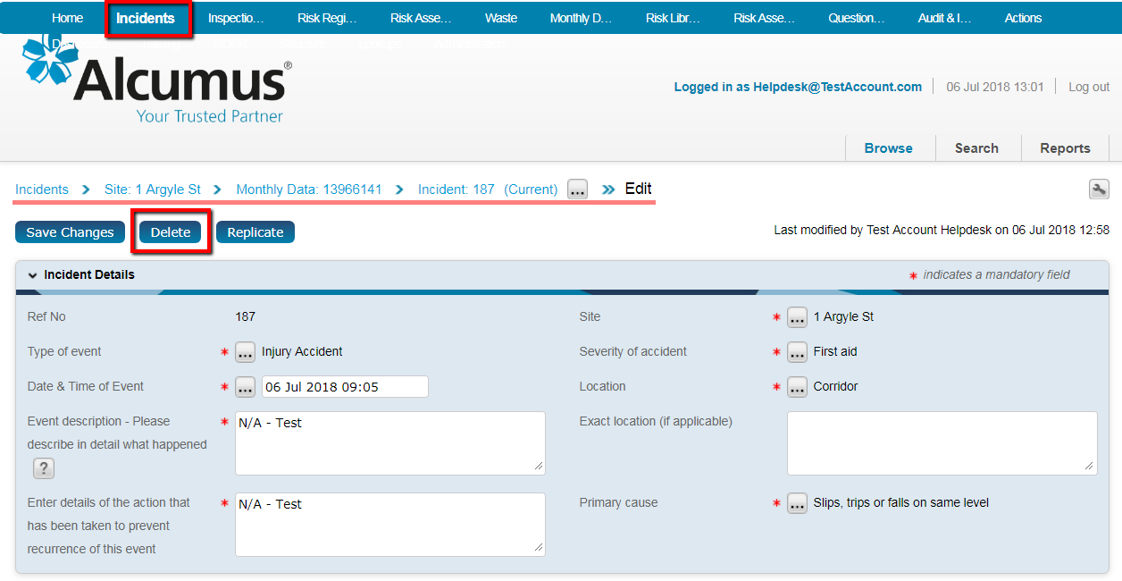
On the Edit page, click on the ‘Delete’ button.
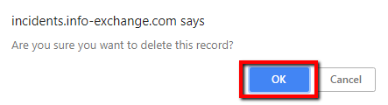
The system will then prompt you to click ‘OK’ once you have decided you are sure you want to delete/archive the record.

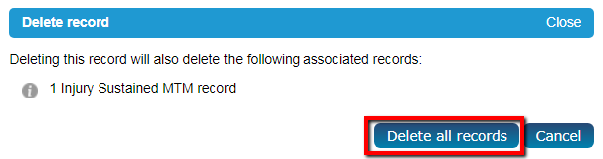

If there are any related records, an additional window will pop up, informing you which associated records will be deleted, should you choose to continue. In order to proceed, click on the ‘Delete all records’ icon.
Once again, click ‘OK’ if you are sure you want to delete/archive this incident and any associated records along with it.

Once the record is archived, it will disappear from the application, and be unavailable until it has been processed; this can take up to 24 hours, as the system is updated once a day.
The archived record will then appear on the Administration module, in Archived records:
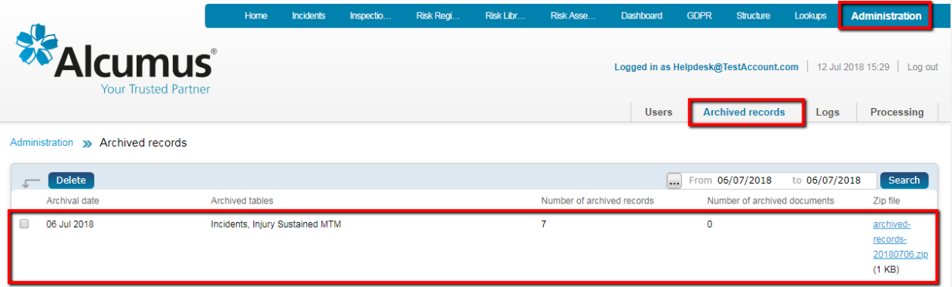
Each Zip file contains all records archived/deleted on any given date.

Help / Guidance Documents Upload
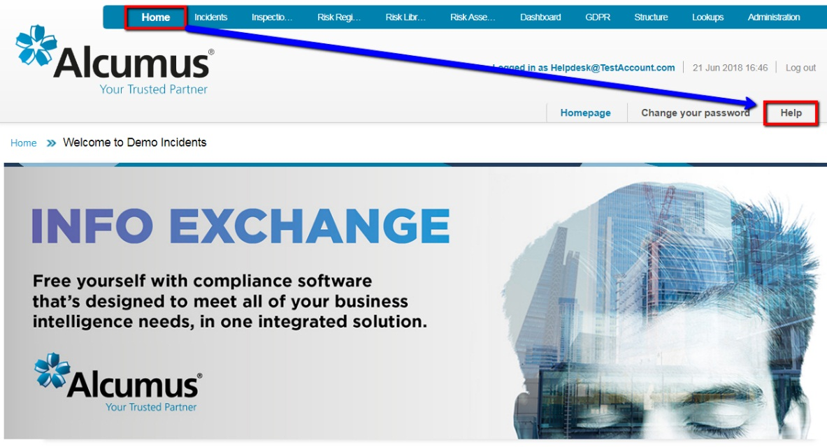
Select Home from the top menu bar and then click on the Help option.

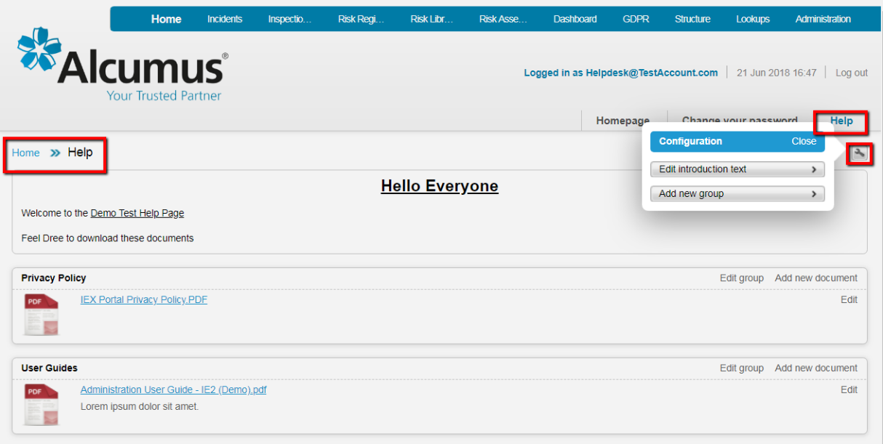
Regular users will be able to view and download any documents available in this area.
Administrators can manage the uploading and grouping of documents by using the spanner icon in the top right corner.

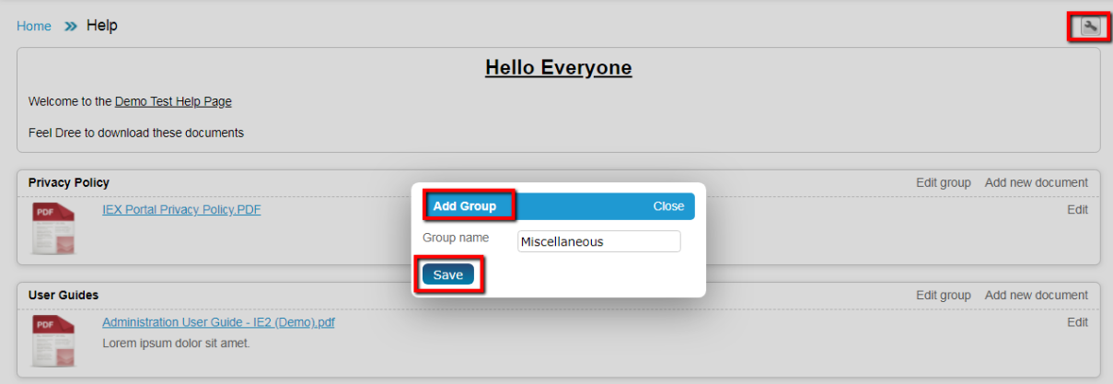
New document groups can also be created from the spanner icon.

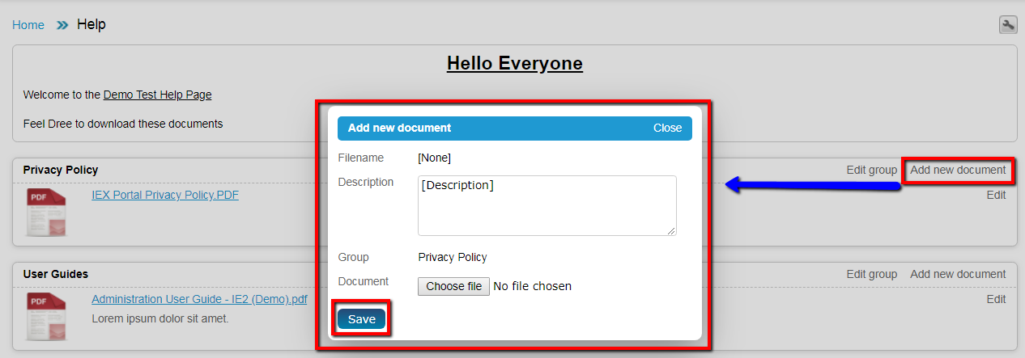
Once a group is created the Administrator can add a document to a group by clicking the Add new document button and entering a description of the document, attaching the file (Document) and clicking the Save button.
Introduction text can be inserted into the top of the page and is edited using the Edit introduction text option from the spanner icon. This is a formatted text box and has controls including font size, colour, bold, italics, etc.
